Experiment Number :11 Date: 25/02/26

Implementation of multiple inheritance in Java using Interface

Aim:
Write a Java program to implement multiple inheritance using Interface.

PRE LAB EXERCISE
QUESTIONS
- Why Java does not support multiple inheritance using classes like that of C?

ANSWER:
Java does not support multiple inheritance using classes because it can create ambiguity, especially in situations like the Diamond Problem.
Instead, Java allows multiple inheritance through interfaces to avoid confusion and keep programs simple.

- What is the primary purpose of an interface in Java?
- To store data using instance variables
- To define a contract of methods a class must implement
- To allow creation of objects
- To improve runtime performance

ANSWER:
B. To define a contract of methods a class must implement

IN LAB EXERCISE
Objective
To demonstrate how an interface in Java defines constants and abstract methods, which are implemented by a class.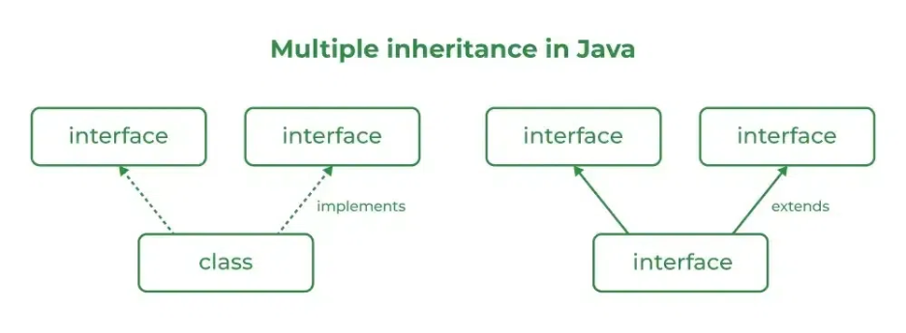

Source Code
import java.io.*;
// Add interface
interface Add{
int add(int a,int b);
}
// Sub interface
interface Sub{
int sub(int a,int b);
}
// Calculator class implementing Add and Sub
class Cal implements Add , Sub
{
// Method to add two numbers
public int add(int a,int b){
return a+b;
}
// Method to sub two numbers
public int sub(int a,int b){
return a-b;
}
}
class Example{
// Main Method
public static void main (String[] args){

// instance of Cal class
Cal x = new Cal();
System.out.println("Addition : " + x.add(2,1));
System.out.println("Substraction : " + x.sub(2,1));
}
}
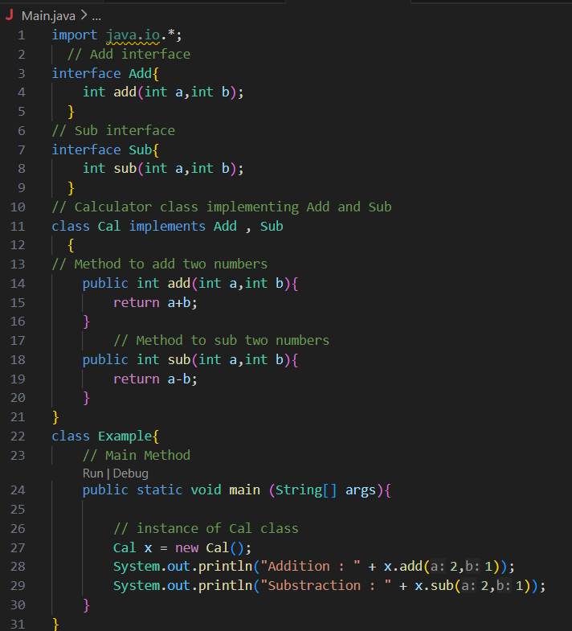
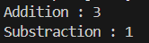
Outputs
Addition : 3
Subtraction : 1

POST LAB EXERCISE
  - Can a functional interface extend another interface?
Yes, a functional interface can extend another interface.
However, it must still have only one abstract method after inheritance to remain a functional interface.
  - Which feature was introduced in interfaces starting from Java 8?
- Constructors
- Private methods
- Default and static methods
- Final classes

ANSWER:
C. Default and static methods

ASSESSMENT

Description | Max Marks | Marks Awarded
Pre Lab Exercise | 5
In Lab Exercise | 10
Post Lab Exercise | 5
Viva | 10
Total | 30
Faculty Signature

Experiment Number : 12 Date: 25/02/26

Implementation of exception handling in Java
Aim:
Write a java program to implement exception handling.

PRE LAB EXERCISE
QUESTIONS
- What is exception handling in Java?

ANSWER:
Exception handling in Java is a mechanism used to handle runtime errors so that the normal flow of the program is not interrupted.
It is done using keywords like try, catch, throw, throws, and finally.

- What is the purpose of using try-catch blocks in exception handling?

ANSWER:
  - try → contains risky code
  - catch → handles the exception

IN LAB EXERCISE
Objective
To understand and implement exception handling through try-catch and finally blocks.
Source Code
import java.util.InputMismatchException;
import java.util.Scanner;
public class ExceptionHandlingExample {
public static void main(String[] args) {
Scanner scanner = new Scanner(System.in);
try {
System.out.print("Enter an integer: ");
int num = scanner.nextInt();
int result = 10 / num;
System.out.println("Result: " + result);
} catch (InputMismatchException e) {
System.out.println("Invalid input! Please enter an integer.");
} catch (ArithmeticException e) {
System.out.println("Cannot divide by zero!");
} finally {
scanner.close();
System.out.println("Program execution completed.");
} }
}
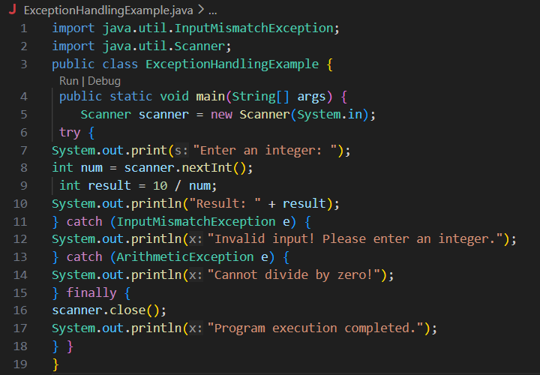
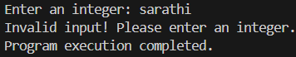
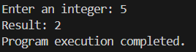
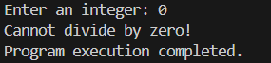
Outputs
Output 1 (Valid Input - Non-zero Integer):
Enter an integer: 5
Result: 2
Program execution completed.

Output 2 (Valid Input - Zero):
Enter an integer: 0
Cannot divide by zero!
Program execution completed.

Output 3 (Invalid Input - Non-integer):
Enter an integer: abc
Invalid input! Please enter an integer.
Program execution completed.

POST LAB EXERCISE
- What is the purpose of the Scanner object in the Java program?
To take input from the user.
- What exceptions are expected to be thrown in the code within the try block? Why?
  - InputMismatchException → if user enters non-integer
  - ArithmeticException → if divided by zero

ASSESSMENT

Description | Max Marks | Marks Awarded
Pre Lab Exercise | 5
In Lab Exercise | 10
Post Lab Exercise | 5
Viva | 10
Total | 30
Faculty Signature

Experiment Number : 13 Date: 25/02/26

Implementation of User-defined Exception in Java

Aim:
Write a java program to implement User-defined Exception.

PRE LAB EXERCISE
QUESTIONS
- What is Java custom exception?
A user-created exception class to handle specific application errors.
- What are the two types of custom exceptions in Java?
  - Checked Exception (extends Exception)
  - Unchecked Exception (extends RuntimeException)

IN LAB EXERCISE
Objective
To understand and implement Checked and Unchecked custom exceptions.
Source Code
Ex 1: // Custom Checked Exception
class InvalidAgeException extends Exception {
public InvalidAgeException(String m) {
super(m);
}
}
// Using the Custom Exception
public class AgeCheck{
public static void validate(int age)
throws InvalidAgeException {
if (age < 18) {
throw new InvalidAgeException("Age must be 18 or above.");
}
System.out.println("Valid age: " + age);
}
public static void main(String[] args) {
try {
validate(12);
} catch (InvalidAgeException e) {
System.out.println("Caught Exception: " + e.getMessage());
}
}
}

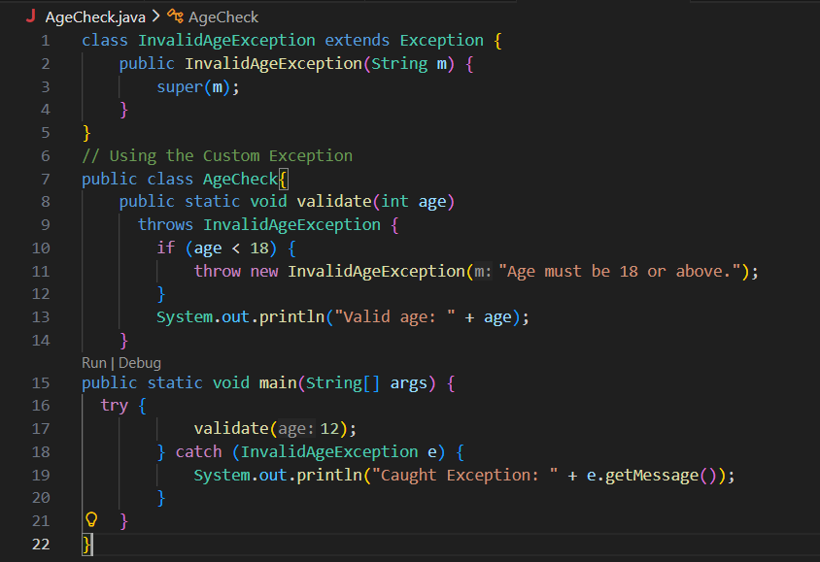

Output 1
Caught Exception: Age must be 18 or above.

Ex 2: // Custom Unchecked Exception
class DivideByZeroException extends RuntimeException {
public DivideByZeroException(String m) {
super(m);
}
}
// Using the Custom Exception
public class TestSample {
public static void divide(int a, int b) {
if (b == 0) {
throw new DivideByZeroException("Division by zero is not allowed.");
}
System.out.println("Result: " + (a / b));
}
public static void main(String[] args) {
try {
divide(10, 0);
} catch (DivideByZeroException e) {
System.out.println("Caught Exception: " + e.getMessage());
}
}
}
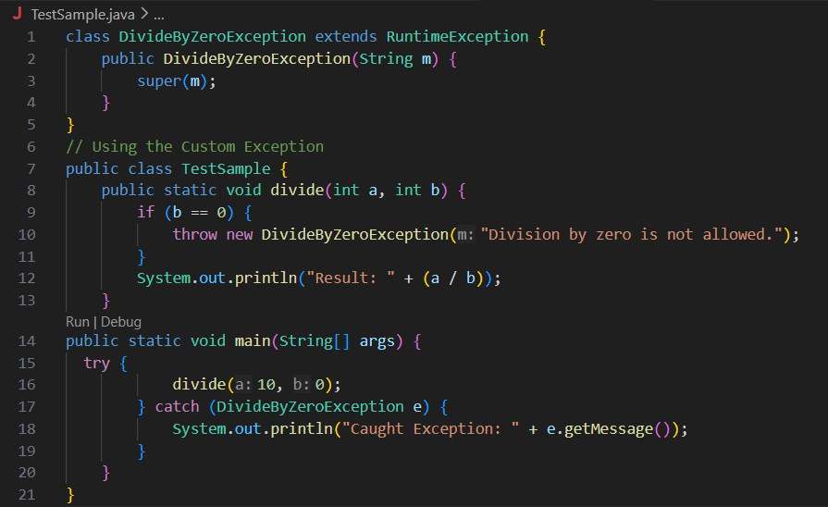

Output 2
Caught Exception: Division by zero is not allowed.

POST LAB EXERCISE
- What is required to create a custom exception in Java?
- Extend the Object class
- Extend the Throwable class
- Extend Exception or RuntimeException
- Implement the Serializable interface
✅ C. Extend Exception or RuntimeException

- List some use cases for the checked and unchecked exceptions.

Checked Exception:
- File handling
- Database operations
- Network errors
Unchecked Exception:
- Invalid input
- Arithmetic errors
- Business rule violations

ASSESSMENT

Description | Max Marks | Marks Awarded
Pre Lab Exercise | 5
In Lab Exercise | 10
Post Lab Exercise | 5
Viva | 10
Total | 30
Faculty Signature

